Sugar Creek Mutual

Insurance Company

Guidelines
&
Rules

for

Solid Fuel Heat
Use & Installation

Contents
General Definitions 3
General Rules 4
General Guidelines 5
Installation of Units 6
Standard Clearances for Solid Fuel Burning Appliances 6
Reduced Clearances When Using Protective Materials 7
Installation of Chimney/Stovepipe 8
Things to Look for When Inspecting a Chimney 9
Agent Inspection & Required Photos 10
Required Photographs 11
Metal Chimney 12
Fireplace Inserts 13
Outdoor Solid Fuel Burning Furnaces 14
Pellet Stoves 15
Pellet Stove Venting 16
Pellet Stove Venting 17
Examples of Proper Setups 18
Examples of Unacceptable Setups 19
Examples of Unacceptable Setups 20
Reference Web Links 21

General Definitions

• Chimney Flue Liner: The passage in a chimney for conveying the flue gases to the outside atmosphere
(clay tile, stainless steel, cast-in-place, etc.).

• Combination Stoves: are designed to burn wood and oil, or wood and gas in one unit with a single stove pipe on a vent connector to the chimney.

• Creosote: A highly flammable oily liquid with a penetrating odor, obtained by distilling wood tar.
When a chimney is caked with creosote, the risk for a chimney fire increases significantly. Proper
firing techniques and regular chimney cleaning will help prevent creosote buildup.

• Double-vent: A solid fuel appliance vented into the same chimney flue as another heating appliance such as an oil furnace. Two separate stovepipes will be entering the same chimney flue at two different locations.

• Factory-built Metal Chimney: There are generally two types of factory-built metal chimneys: double- wall insulated or triple-wall ventilated. Both have stainless steel liners. Factory-built chimneys for use with solid fuel heating appliances must be listed to UL-103HT and/or ULC-S629M specifications. Factory-built metal chimneys have been on the market for several years and prior to the early 1980’s were listed to a less stringent standard.

• Fireplace Insert: Like a woodstove, but is designed to be installed within the firebox of an existing masonry fireplace. Inserts are used to convert masonry fireplaces into more effective heating systems. A stainless-steel chimney liner should be from the fireplace insert to the top of the chimney. The result is better performance and a safer system.

• Floor Protector: A noncombustible surfacing applied to the floor area underneath and extending 18” in front, to 18” on the sides, and 36” to the rear of a heat producing appliance. (NOTE: These are
available commercially at wood heating equipment dealers.)

• Heat Savers/Heat Reclaimers: A device installed between the stove and the chimney. They are designed to draw heat away from the stovepipe and distribute it in the immediate room. These devices reduce the temperature in the chimney flue and may cause excessive creosote accumulation in the stovepipe and chimney.

• Pellet Stoves: Stoves that burn pellet fuels made from wood, corn or other biomass wastes. Typically, automatic operation using electric auger to move the fuel to combustion chamber, exhaust fan and circulating fan, simple venting, low emissions, and high efficiency.

• Single-vent: One solid fuel appliance vented to one single chimney flue.

• Single-wall Metal Chimney: A single-walled metal/iron pipe suitable only for stovepipe use. Use of single-wall metal pipe, stovepipe or iron pipe will not be permitted as a chimney for solid fuel burning appliances.

• Spark Arrestors: Screening material or a screening device attached to a chimney termination to prevent the passage of sparks and brands to the outside atmosphere.

• Solid Fuel: Wood, coal, pellet, corn and other similar organic materials and any combination of them.

• Stovepipe: The chimney connector (or vent connector ) is commonly known as a “stovepipe.” This single-wall metal pipe is not a chimney!

• Thimble: A fixed or removable ring, tube or lining usually located in the hole where the chimney connector or vent connector passes through a wall, ceiling, or enters a chimney or vent.

• Wall Protector (shield): Noncombustible surfacing applied to a wall area for the purpose of reducing the clearance between the wall and a heat producing appliance.

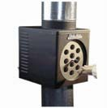
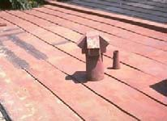
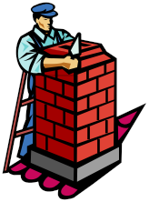
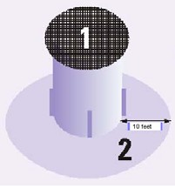

General Rules

• No heat saving/heat reclaiming devices on solid fuel stoves.

• Use of single-wall metal pipe, stovepipe, or iron pipe will not be permitted as a chimney for solid fuel burning appliances.

• Barrel stoves are not permitted.

• Home-built stoves are not permitted.

• Solid fuel in rental dwellings is not permitted.

• Solid fuel units will not be permitted in garages that are attached to a dwelling, or closer than 25 feet. Solid fuel units will not be permitted in buildings where there are flammable vapors.

• Double venting is not allowed.

• Triple venting is not permitted.

• Fireplace inserts with a metal chimney are not permitted.

• Burn barrels must be at least 100 feet away from all structures. Always cover your burn barrel with 1/4” or smaller metal mesh screen. (1) Clear away any debris for at least 10 feet around your burn barrel and work up the area to expose the soil. (2)

• Solid fuel units as the only source of heat are not acceptable.

• All chimneys must be properly lined.

• Unlined chimneys are not acceptable without underwriting approval.

• Solid fuel units in commercial buildings are not acceptable without underwriting approval.

• Supplemental solid fuel units or fireplaces are not
permitted in Mobile Homeowners or Mobile Fire and
Extended coverage policies.

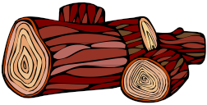
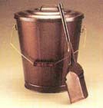
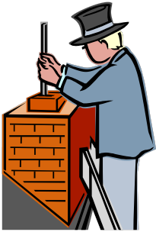

General Guidelines

• Ash disposal – place ashes in a metal container equipped with a lid or cover, and place the container outside and away from buildings and combustibles.

• Wood – store wood at least 48 inches away from the solid fuel heating appliance. Keep the area and floor surrounding the heating appliance clear of combustibles and wood chips, bark, and debris.

♦ Only dry and well-seasoned hardwood should be burned. Season wood at least six months, preferably a year to eighteen months. Wood burners who ignore this advice are likely to have dirty chimneys and inadequate heat from their stoves.

♦ If green wood is purchased, it should be seasoned before use. With some experience, you can spot green wood easily. It is heavier and looks different. Seasoned wood will often show cracks radiating outward from the heartwood toward the bark, like wheel spokes. Green wood will not show this pattern of cracks.

• Testing by agency – buy only solid fuel heating appliances and accessories that have been tested or listed by a recognized agency such as: UL (Underwriters Laboratories); BOCA (Building Officials and Code Administrators); ICBO (International Conference of Building Officials); or independent laboratories such as Warnock Hersey or equivalent.

• Cleaning - cleaning creosote on a regular schedule is a must for safe operation. Clean the chimney when creosote deposits are one-quarter inch thick. New stove installations should be inspected every few weeks until you determine creosote buildup rates. The stovepipe must also be checked for soot and creosote buildup. A quality steel bristled chimney brush is a
good investment for cleaning. Remember:

♦ Cooler surfaces will have thicker creosote deposits.

♦ Outside chimneys may require more frequent cleaning.

♦ Efficient solid fuel heating appliances generate creosote much faster because of long, slow burning.

♦ Different species of wood and switching from heavy heating to light heating can affect creosote buildup too.

• Safety Equipment:

♦ Smoke Detectors - are required for dwellings and apartments, with one detector required on each level of the home and one in each bedroom. Install only UL listed smoke alarms, test them often, and change batteries once a year.

♦ Carbon Monoxide Detectors - Every fuel burning device in a home is a potential carbon monoxide source. Detectors that are UL listed are set to sound an alarm at high and low levels. At least one CO detector should be in the insured’s home. It should be tested and maintained.

♦ Fire Extinguishers - are required in homes and outbuildings where solid fuel heating systems are used. Fire extinguishers should also be in kitchen and workshop areas. Purchase type ABC dry-chemical extinguishers which are refillable and equipped with a flexible hose. Preferable sizes are 5-lb and 10-lb.

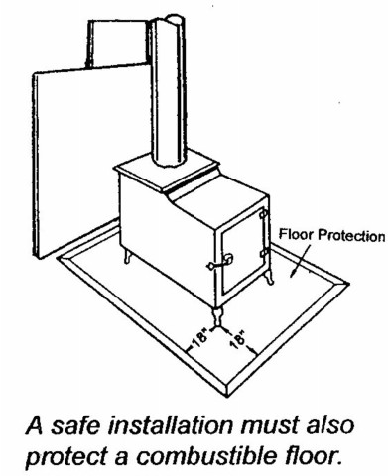
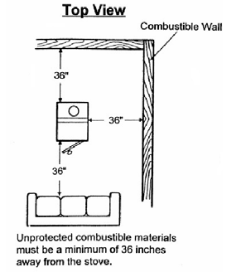
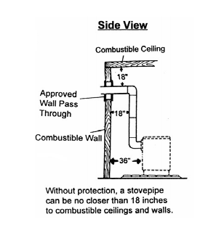

Installation of Units

Wall and ceiling floor protection needed – a minimum of 36” on top and all sides of the
stove. A single wall stovepipe must have an 18” clearance to combustible walls and ceilings.
Sheet rock (drywall) on wood framing is considered combustible.

Standard Clearances for Solid Fuel Burning Appliances

Above top of casing or appliance.
Above top and sides
of furnace plenum From From From
Kind of Appliance or bonnet Front Back (1) Sides (1)

Room heaters, Fireplace
stoves, Combinations 36 in. 36 in. 36 in. 36 in.

Furnaces (Gravity, Forced air, Dual-fuel and
Add-on) 18 in. 48 in. 18 in. 18 in.
Residential appliances 6 in. 48 in. 6 in. 6 in. Steam Boilers – 16 psi
Water Boilers – 250 deg. F max Water Boilers – 200 deg. F max All Water Walled or Jacketed

(1) Provisions for fuel storage must be located at least 36” from any side of the appliance.

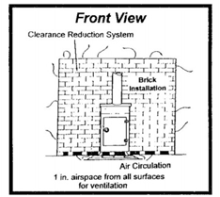
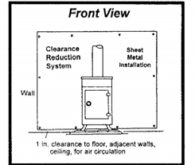
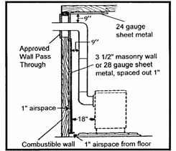
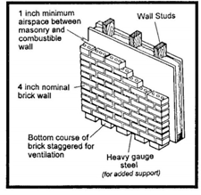
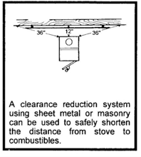

Reduced Clearances When Using Protective Materials

 | Combustible Surface Covering | As Wall Protector (Stove) | As Ceiling Protector (Stove) | Wall or Ceiling (Stovepipe)
 | 3 ½ inch thick masonry wall without ventilated airspace | 24 in. | ------- | 12 in.
 | ½ inch thick noncombustible insulation board over 1 inch glass fiber or mineral wool batts without ventilated airspace | 18 in. | 24 in. | 9 in.
 | 3 ½ inch thick masonry wall with 1 inch ventilated airspace | 12 in. | -------- | 9 in.
 | 24 gauge sheet metal with  1 inch ventilated airspace | 12 in. | 18 in. | 9 in.
 | ½ inch thick noncombustible insulation board with 1 inch ventilated airspace | 12 in. | 18 in. | 9 in.
 | 1 inch glass fiber or mineral wool batts sandwiched between two sheets of 24 gauge sheet metal with 1 inch ventilated airspace | 12 in. | 18 in. | 6 in.

See illustrations below

Installation of Chimney/Stovepipe

For proper draft and to prevent fires from sparks, the chimney should extend three feet above the roof and at least two feet above any portion of the building within ten feet.

3 feet minimum from roof penetration

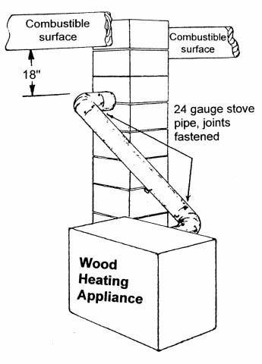
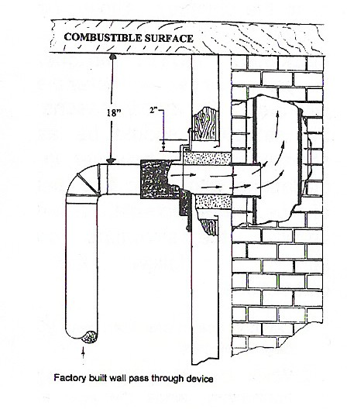
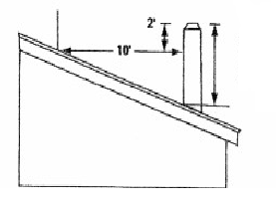

The chimney connector, or vent connector, is commonly known as a “stovepipe.” This single- wall metal pipe is not a chimney! It connects
the stove to the chimney. It should not pass through any wall, floor, ceiling, or through a fire wall or partition without a factory-built pass- through device*. The stovepipe should be as short as possible; however, installations with up to five feet of pipe are acceptable.

1. Do not use more than two 90-degree elbow joints.

2. When the stovepipe is going horizontally, slope
the pipe at least one-quarter inch rise for each foot of pipe length. (This slope should be toward the stove to allow creosote to run back into the stove.)

3. All pipe joints should be fastened with at least three sheet metal screws.

4. The crimped end of the pipe should be installed towards the stove. This will allow creosote and moisture to drip back into the stove.

5. The stovepipe cannot be less than 18 inches from combustible ceilings or walls unless proper protection is used.

* A factory-built wall pass-through device is a high heat resistant thimble and insulating sleeve for use when the stovepipe must pass through any combustible wall.

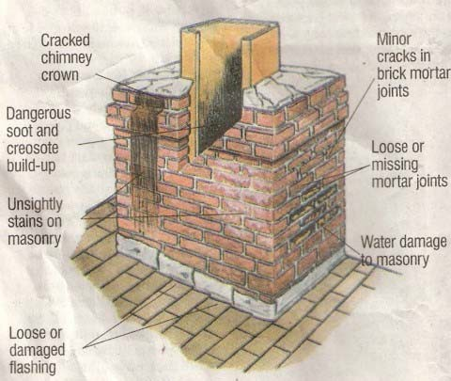

Things to Look for When Inspecting a Chimney

Inspecting – Insured’s should inspect their chimneys, fireplaces, and vents at least once a year for soundness, freedom from deposits and correct clearances. Chimneys should be inspected monthly, when in use, for buildup of creosote deposits and cleaned when one-quarter inch or more buildup exists. Connectors, spark arrestors, clean-outs and tee fittings for chimneys and for pellet venting systems are to be inspected at least once a year for soundness and creosote deposits.

Insured’s should also look for damaged or deteriorated liners, and leaks or cracks in the chimney. Leak tests should be done on newly installed chimneys.

Agents: If you cannot determine if a chimney is lined and the insured also does not know, contact the company before binding. A professional should be contacted to verify soundness and safety of the chimney.

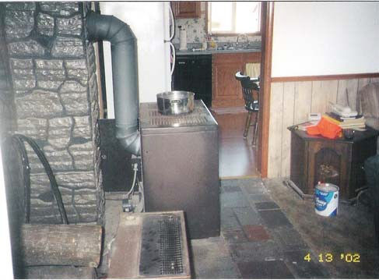
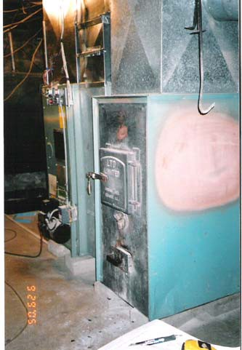

Agent Inspection & Required Photos

♦ Photos of the solid fuel unit are required along with a completed supplement. Photos should show front and back of the unit, as well as where the stovepipe connects to the chimney and all wall/ceiling chimney pass-throughs.

♦ Our inspectors cannot schedule appointments on every occasion to get inside and inspect solid fuel units. It is the agent’s responsibility to provide the necessary information and photos for underwriting to determine acceptability.

Front of heating unit example

Rear of heating unit example

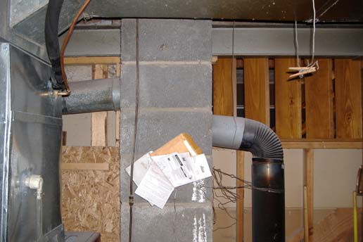
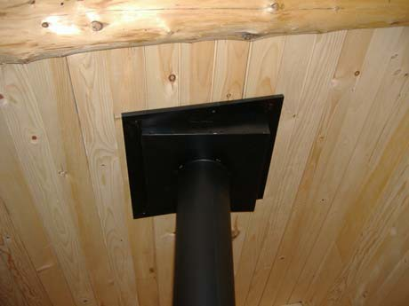
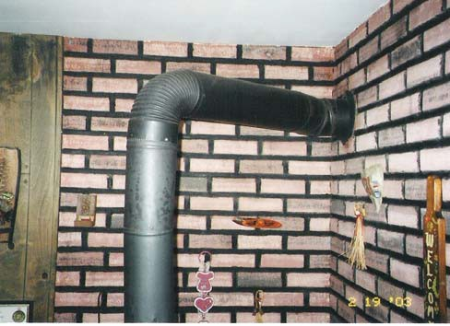

Required Photographs

Stovepipe connection to the chimney

(Notice there are two stovepipes connected to the same chimney flue. This is double-vented.)

Ceiling pass-through example

Wall pass-through example

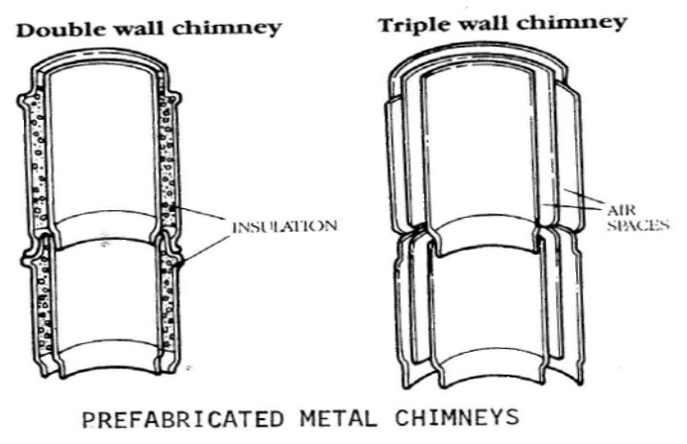
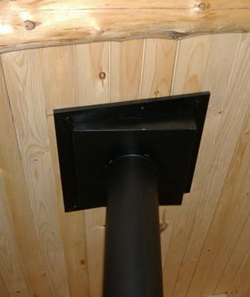

Metal Chimney

Coverage for wood stoves using pre-fabricated metal chimneys instead of a lined masonry chimney may be written by Sugar Creek Mutual Insurance. However, certain specifications must be met:

1. The chimney must be a double-wall chimney or a triple-wall chimney. Single- wall metal chimneys are not allowed. The illustration below left shows a cross- section view of the double- and triple-wall chimney. Notice that both types of chimneys have insulation or air spaces between the walls to diffuse the heat from the stove.
2. Prefabricated metal chimneys should be UL-approved and listed as UL-103HT and/or ULC629M. The listings are relatively new and require that the manufacturers submit their products to 2100 degrees Fahrenheit flue gas temperature. The UL label is stamped on each section of the chimney. If there is no stamp, the chimney should be replaced with a properly listed product.
3. A 2-inch clearance is required between the chimney exterior and any combustible material.
4. Attic insulation should be a minimum of six inches away from the metal chimney.
5. When inspecting metal chimneys, look for discoloration, warping or distorting, loose or leaky joints, or other visible damage.
6. A metal pass-through or “thimble” should be used when going through ceilings or walls. See photograph below right.

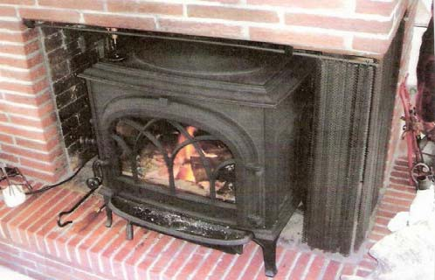
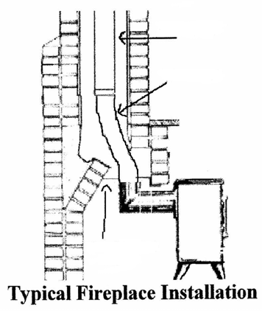

Fireplace Inserts

A fireplace insert is a heating unit that is designed to be installed within the firebox of an existing masonry fireplace. Sugar Creek Mutual Insurance will allow coverage for fireplace inserts as long as they have been properly installed. A solid fuel burning surcharge will apply to the policy.

In the “old days” wood stoves, such as potbelly stoves, were places in the firebox of an existing fireplace and the stove pipe was vented up toward the damper area. Sometimes fiberglass insulation was placed around the stove pipe to prevent too much room air from escaping up the chimney and to provide a stronger stove draft. However, chimney professionals soon saw that there were a lot of problems with this setup. This installation method created a lot of creosote because the stoves drafted poorly, and the chance of a chimney fire increased greatly.

Today professionals, such as the National Fire Protection Association and National Association of Mutual Insurance Companies (NAMIC), have put together some guidelines for fireplace insert installation and safety.

• Before installing a fireplace insert, determine if the fireplace chimney is masonry or a metal (zero clearance) fireplace with a metal chimney. Only a few fireplace inserts are tested for use in the metal fireplace or “pre-fab” units. The insured should confirm proper installation with the fireplace insert manufacturer’s manual or literature.
• The flexible stainless steel tube that extends from the fireplace insert up through the damper must extend five feet minimum and connect to a stainless steel chimney liner that extends to the top of the chimney.
• The chimney must be lined.
• The area below the fireplace damper should be sealed with a metal plate. Furnace cement or high temperature silicone should be used as sealant.
• A cap or spark arrester should be installed on the chimney top.
• The hearth of the fireplace should extend at least 18 inches in front of the fireplace insert doors.
• There should be 36 inches from the front
and sides of the insert to any combustible.

Rigid Pipe

(stainless steel chimney liner

Flex Tube
(stainless steel)

)

Sheet Metal
Plate

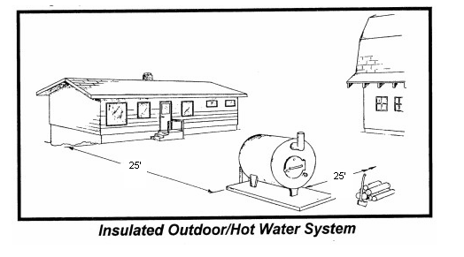
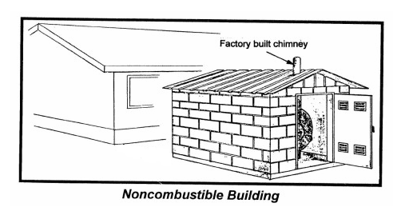

Outdoor Solid Fuel Burning Furnaces

The two types of outside solid fuel burning systems are forced air and hot water, with hot water being the predominant system. However, within four to six years hot water system tanks tend to fail due to corrosion. Upon losing water, the system overheats resulting in a warped firebox and often total destruction of the heating furnace. Additional fires result from wood being stored too close to the furnace area, poor housekeeping of wood chips, bark and debris around the furnace area, and improper handling and storage of ashes removed from fireboxes.

1. Outdoor solid fuel burning furnaces must be located a minimum of 25 feet from any building.
2. Underwriting consideration will be given when outdoor furnaces are installed inside non-
combustible buildings. A residential type masonry or factory built chimney is required. All chimney clearance requirements must be met. No binding. Contact underwriting.
3. Installation and regular inspections should be made by a reputable contractor familiar with this type of system.
4. Store firewood at least four feet from the furnace.
5. Spark arrestor screens should be installed on outdoor wood heat system vents or chimneys.
6. Proper foundations should be of concrete or similar materials to prevent heaving.
7. Units should be placed out of vehicle traffic away from trees and shelterbelts, and ideally within sight of
the dwelling.
8. Coverage for unit itself is included in the Coverage A limit if it serves the dwelling in any way.
9. Coverage for the unit itself, if serving only an outbuilding, will need to be scheduled under
Coverage B or Coverage F.

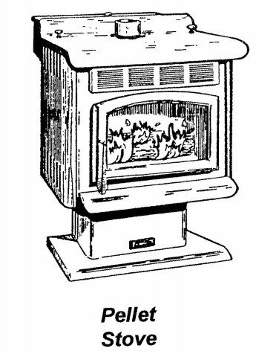

Pellet Stoves

Stoves that burn pellet fuels -- made from wood, corn, or other biomass wastes -- have been widely available for several years. Pellet stoves have some advantages over wood stoves that burn firewood:

♦ The automatic operation is convenient.
♦ One hopper-load of fuel can last 24 hours or more.
♦ The fuel is supplied in compact bags that store neatly.
♦ Most can use a special vent that costs less than wood-stove chimneys.
♦ They can offer low emissions and high efficiency.

Balancing these advantages are some limitations that you should consider:

♦ Pellet stoves tend to cost more.
♦ Pellet fuel is more expensive than firewood in many areas.
♦ Most pellet stoves need electricity to drive auger motors and fans.
♦ Flames produced by pellet stoves don’t look as natural as wood fires, although this feature has improved.

At the same time, pellet stoves usually have three motorized systems that require electricity:

1. A fuel feed auger to move the fuel from the storage hopper to the combustion chamber;
2. An exhaust fan to move the exhaust gases through the appliance and into the venting system while drawing in combustion air; and
3. A circulating fan to force air through the heat exchanger and into the room.

A few pellet stoves can operate during electrical power failures by using batteries to operate the motors.

Although stoves are the most common pellet-burning appliances, you may also find fireplaces and central heating furnaces that burn pellet fuel in your area.

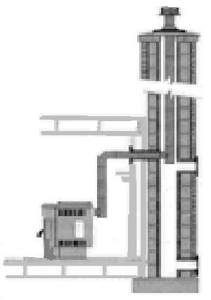

Pellet Stove Venting

What are the purposes of venting systems?
Proper venting is essential for proper appliance performance, dwelling safety, maintenance frequency, and indoor environment. Pellet stoves produce little or no visible smoke after startup,
but exhaust gases, fine ash, and water vapor must be removed safely from the appliance to the
outdoors without leaking into the house. The purpose of all vents is removal of combustion by- products during normal operation. For most designs, the exhaust is mechanical: a fan blows the combustion by-products out and pulls air needed for combustion into the fire. A few stoves operate without a combustion air fan and use natural draft both for exhaust and combustion air intake. Some heat also moves through the vent. Protection of nearby combustibles is essential. The minimum clearance between the vent and combustibles, as specified in the vent installation instructions, must be met or exceeded to assure safety.

What materials and products can be used to vent pellet stoves?
The product specifically tested and listed for use with pellet stoves is PL vent pipe, labeled as tested to UL 641. PL vent pipe is double-wall pipe; the stainless steel inner pipe that carries the exhaust products is separated from the outer wall by an air space. Pipe joints must be sealed gas tight to prevent exhaust products moving through the vent under pressure from leaking into the home. Stoves tested and listed requiring PL vent must use no substitute venting materials.

Venting materials and products NOT TO BE USED to vent pellet appliances:
♦ Dryer vent
♦ Gas appliance (type B) vent
♦ PVC (plastic) pipe
♦ Single-wall stove pipe (unless clearly approved by the installation manual and local codes)

Pellet fireplace inserts and freestanding stoves are often vented into existing masonry and factory-built fireplace and woodstove chimneys. The chimney should be inspected before installation to ensure that it is clean, mechanically sound, and meets local safety code requirements. The appliance manufacturer's installation instructions may require relining the chimney with an approved metal liner, pipe, or PL vent. Vents or grilles on the face of factory- built fireplaces which provide cooling air to the outside jacket of the fireplace must not be blocked. Cleanout access for future maintenance should be considered.

Besides appliance requirements, what other factors may be considered in specifying pellet venting systems?
The following factors may play a role in the designation of the venting system:

* House Pressure: Extremely tight house construction or strong kitchen, bath, or other exhaust fans may create a negative pressure within the home that decreases venting effectiveness. May necessitate an approved outside air source.

* Windy Conditions. Unpredictable effects of high winds or prevailing wind conditions may necessitate the addition of vertical venting extending above the roof and/or special termination caps.

* Cleanout and Maintenance: The venting system must be designed with normal maintenance in mind.

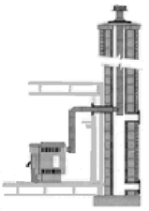
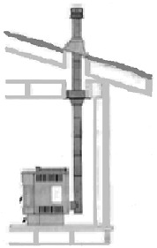
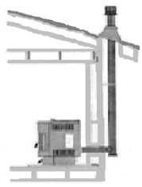
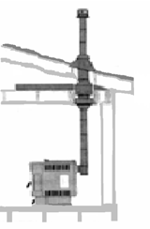
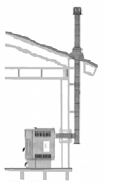
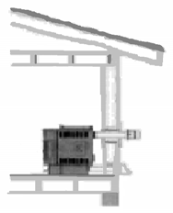

Pellet Stove Venting
What are my options for venting layout? Mechanical Exhaust:

• Sidewall horizontal venting. Invariably the least expensive venting system. Disadvantage of potential smoke spilling into the house in the event of a power outage or component failure, or house depressurization.

• Horizontal vent with backup vertical venting.
Preferred horizontal method that avoids venting problems associated with unexpected appliance shutdown.

• Vertical venting through the ceiling and roof has the advantages of keeping vent gases warm and of providing natural draft to prevent problems in an unexpected shutdown.

• Venting into existing chimney. Stove manufacturers provide recommendations for
venting into masonry and factory-built chimneys, which may include partial or full chimney relining.
• Natural draft. All vents for appliances designed without mechanical exhaust fans must meet stove manufacturer’s requirements for minimum draft and
must terminate above the roof.

• Vertical extends up from the stove and penetrates the ceiling and roof. Horizontal and vertical extends from the top or back of the appliance, penetrates the wall, turns up to penetrate the eave and roof. Venting into existing chimney: follow manufacturer’s recommendations for venting into masonry and factory-built chimneys, which may include partial or full chimney relining.

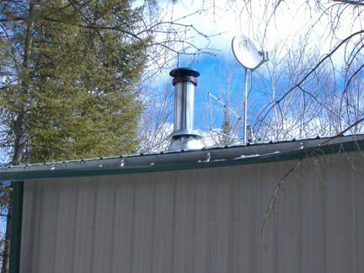
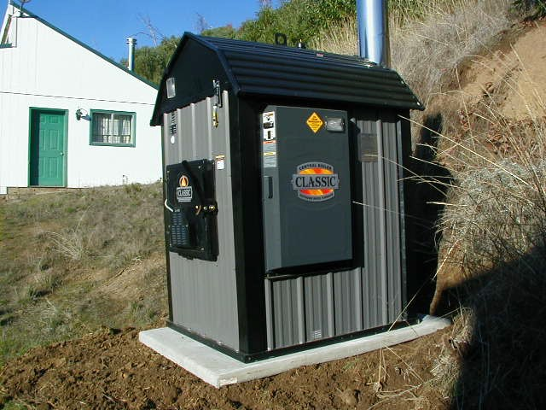
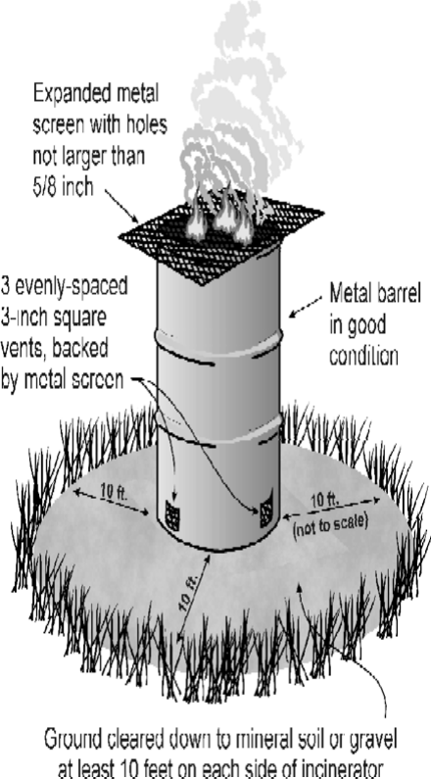

Examples of Proper Setups

Properly installed metal chimney Triple wall stainless steel chimney with proper roof thimble and proper height.

Properly placed outside wood stove More than 25 feet from any structure, not housed inside/alongside another structure.

Correct setup of burn barrel

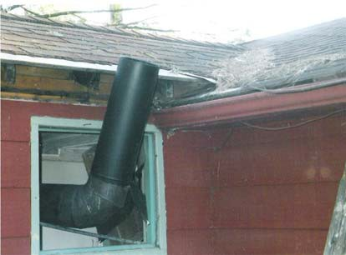
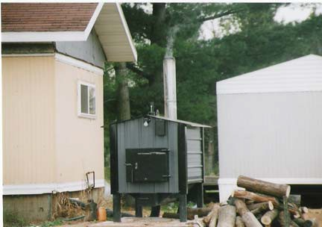
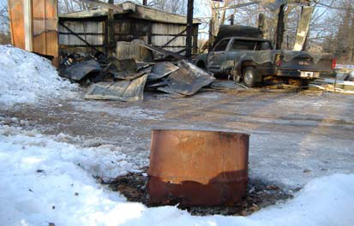
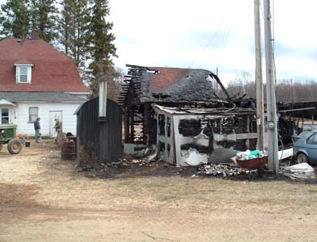
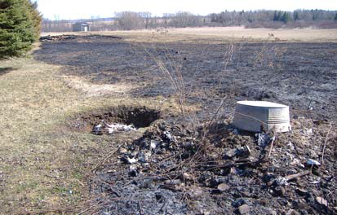

Examples of Unacceptable Setups

Improper chimney setup improper single-wall metal pipe as chimney Improper wall pass-through,

nd
a improper chimney height.

Possible consequences from an
Improper outdoor wood furnace setup improper outdoor wood furnace setup

Less than 25 feet from any structure, improper chimney height, fuel closer than four feet, and poor housekeeping.

Possible consequences of improperly placed burn barrels

Less than 100 feet from any structure, no No burn barrel at all; only a pit next to an open, screen, barrel in poor condition. grassy field. (Notice the burned-down building
in the background)

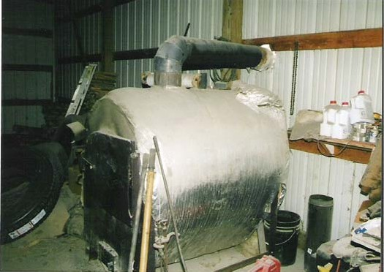
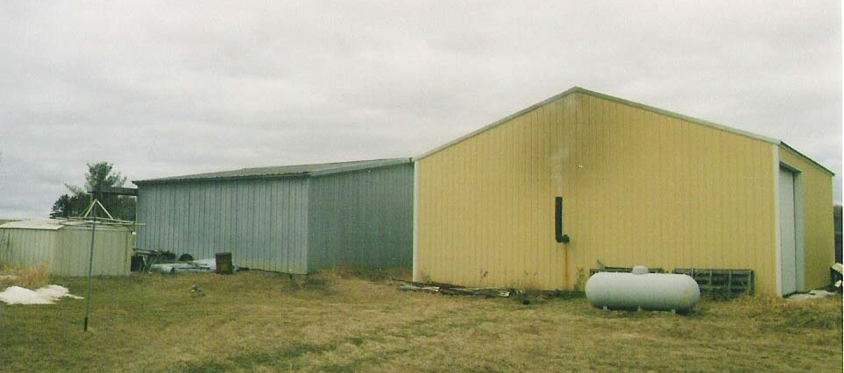
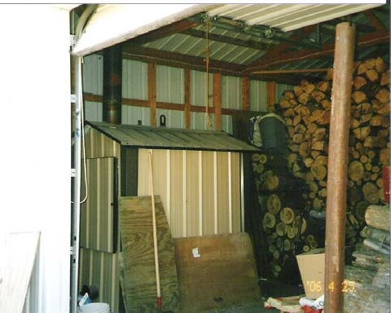

Examples of Unacceptable Setups

Inside

Single-walled metal stovepipe used as chimney; improper stovepipe clearance to combustibles (note notch cut out of framing lumber which is within inches
of the stovepipe.)

Outside

Long grass and debris underneath chimney; LP gas tank located too close to chimney.

An outdoor wood furnace improperly installed inside another structure. Fuel stacked ceiling high and
within 4 feet; excess debris around furnace.

Reference Web Links

www.csia.org Chimney Safety Institute of America www.outdoorwoodfurnaces.org How to Buy an Outdoor Furnace www.ul.com Underwriter Laboratories, Inc. www.nfpa.org National Fire Protection Association www.firewise.org Fire Wise Communities
www.pelletheat.org Pellet Fuel Institute
www.stovekeeper.com Stove Keepers
www.hpba.org Hearth, Patio, & Barbecue Association
www.woodheat.org Wood Heat Organization

Disclaimer:
The information and recommendations contained in this manual have been obtained from sources which we believe to be competent and reliable, and tend to represent the best opinion on this subject.

Sugar Creek Mutual Insurance Corporation does not make any warranty, guarantee, or representation as to whether or not any representation is absolutely correct or sufficient. No responsibility is assumed by Sugar Creek Mutual, and it cannot be assumed that all acceptable safety measures are listed in this manual. Under particular circumstances or conditions it may be that additional measures may be required for the safe installation and operations of a solid fuel heating system.
Please follow all applicable building codes and manufacturer recommendations.

